Chiba University Leading Research Promotion Program
Online International Seminar (in English)

Positive Political Psychology International Seminar 2:
Social Fairness and Wellbeing
Date & Time：22 Feb. 2023(Wed), Japan

Abstract: This is a research essay based on the transcript of the seminar “Positive Political Psychology International Seminar 2: Social Fairness and Wellbeing”. Professor Arthur Grimes (professor of Wellbeing and Public Policy from School of Government, Victoria University of wellington, New Zealand) addressed the challenges for a post-covid fair society from the perspective of social fairness and wellbeing. Associate Professor Aaron Jarden (wellbeing consultant, keen traveler, and director of the maters of applied positive psychology, University of Melbourne, Australia) initiated the discussion, and research ideas were exchanged afterwards.

Moderator
・Prof. Hikari Ishido (Chiba University)

Panelists
・Prof. Arthur Grimes (Victoria University of Wellington)
・Assoc. Prof. Aaron Jarden (The University of Melbourne)
・Prof. Jiro Mizushima (Chiba University)
・Prof. Masaya Kobayashi (Chiba University)
・Prof. Takayuki Kawase (Chiba University)
・Mr. Alfonso Torrero (Universidad Autónoma Metropolitana)

Organizer: Chiba University Global Fair Society Program

Introduction (by Prof. Hikari Ishido)
This online seminar is entitled “Positive Political Psychology International Seminar 2: Social Fairness and Wellbeing”. We will have Professor Arthur Grimes (professor of Wellbeing and Public Policy from School of Government, Victoria University of wellington, New Zealand) to talk about the challenges for a post-covid fair society from the perspective of social fairness and wellbeing. Then we would like to invite Associate Professor Aaron Jarden (wellbeing consultant, keen traveler, and director of the maters of applied positive psychology, University of Melbourne, Australia) to make comment and initiate today’s discussion. Professor Jiro Mizushima and Professor Masaya Kobayashi and other participants will join the discussion and exchange research ideas afterwards.

Opening remark (by Prof. Jiro Mizushima)
Today, we are very happy that we have honorable guests from New Zealand and Australia who will kindly speak about wellbeing and public policy. I am a political scientist, and I am especially interested in the theme about wellbeing and public policy and politics. What can we do to increase the wellbeing that drives satisfaction by way of intervention of the government or civil society? This problem is quite acute because as we know, we have all experienced the huge impact of COVID-19 in these three years, in most cases, negative impact on the wellbeing of human beings. In this situation, we must know what we can do to overcome these challenges. Today, I am very excited that we have two famous experts on this field. I believe that this online symposium would make a great contribution to understanding of wellbeing and public policy, and it will promote our international cooperation between Japan, Australia, and New Zealand. I see that we have also a participant from Mexico, from American continent. This is truly a Pacific symposium. Thank you very much.

Wellbeing and Public Policy: Challenges for a Post-Covid Fair Society (Presented by Professor Arthur Grimes)
As an economist, I’m very interested in thinking about how issues of wellbeing can be brought to public policy. For that reason, one of the stresses that I will put in as you will detect through the discussion is how we can use concepts of wellbeing for policy purposes. Not just for academic purposes but when we are trying to design policy and especially if we’re interested in as you are in issues of fairness not just of average outcomes across society.
In terms of the talk, the main outline is, how can we think about wellbeing and fairness together and how can we use those concepts to guide policy? I’ll start off by noting to start with this, how wellbeing approaches to policy are not new. They have a very long history back to antiquity and then also over the last few centuries. I will follow that by discussing, what do we mean when we talk about wellbeing? I’ll briefly outline two different wellbeing approaches that have been used in the policy arena. Each of those has also been used to incorporate fairness considerations. There are two main conceptual bases as opposed to thinking about wellbeing and policy. I’ll talk briefly about some country experiences, different countries that have used wellbeing oriented public policies. I’ll talk about six different countries there based on a recent paper that I’ve published on that, and then I’ll discuss some examples of using wellbeing as a guide for policy.
When we think about the history of wellbeing approaches, we can go back about 2500 years. I love this quote from Confucius around 500 B.C. “There is good government when those who are near are made happy and when those who are afar are attracted.” In other words, governments can be judged if the people that live within their boundaries are happy and where the other people who from outside the boundaries wish to move to that entity. It’s a very nice summary I think although it doesn’t necessarily include much about fairness. At roughly the same time, a couple of hundred years later, on the other side of the world, in ancient Greece, Epicurus’ school motto was “Here our highest good is pleasure”. In other words, the idea that when people went to school was that they should be enjoying themselves, they should be having pleasure, they should be happy etcetera. These are similar ideas on other sides, different sides of the world, 2500 years ago. If we skip forward a couple of thousand years and we move to the period of the European enlightenment, a very famous statement of the utilitarian view of the world was from the philosopher and economist lawyer, Jeremey Bentham in 1776 saying, “It is the greatest happiness of the greatest number that is the measure of right and wrong.” It’s quite a similar concept to the Confucius quote which is when we’re thinking about what the government is doing whether it’s working on policies that are right or wrong, and are they making a large number of people happy? Again, it’s not necessarily related to fairness in this case because he is just thinking about really the averages across society. A person who did think about fairness around the same time was Mary Wollstonecraft in England writing a book entitled “A Vindication of the Rights of Woman”, which was saying that it’s only fair that women should be treated with the same rights as men. Interestingly, Jeremey Bentham I should have mentioned used his approach to say that the happiness of all people in society was important, whether it was women or men. I think he included homosexuals and heterosexuals. He even extended it to people who believed in God or didn’t believe in God etcetera. He was thinking about the whole society. A couple of generations later, John Stuart Mill, a great economist and philosopher again had a similar idea, “A moral agent should choose the action that maximizes the total happiness in the world.” So again, he was talking about the role of government in this and other decision makers. So, we have a sort of period out of the European enlightenment which really emphasized wellbeing. They tended to use the word happiness or utility at that time. And in the case of Bentham and Wollstonecraft in particular, the happiness of everyone in society.
A different form of wellbeing which is referred to by Aristotle back again in the ancient Greek times, and more recently, it’s come to be known by the term eudaimonia which was a term that Aristotle used, a sort of purpose in life. How wellbeing might by our purpose in life was very nicely summarized by Bobby Kennedy in the year that he was assassinated in a speech to Kansas University where he said, “Even if we act to erase material poverty, there is another greater task. It is to confront the poverty of satisfaction, of purpose and dignity that afflicts us all.” He was saying we shouldn’t be just looking at material items when it comes to wellbeing or happiness and nor were those other philosophers I quoted. But we should be thinking more deeply about what it is that makes life meaningful for all, that afflicts us all. He wasn’t just talking about a few. He was talking about all. So, we have these slightly different notions of wellbeing. They are all important when it comes to policy purposes.
As an economist, I try and give some tighter definition when I’m talking about wellbeing because I want to use the concept to be able to prioritize public policies. And for that purpose, I need to have a tighter definition of wellbeing than just as sort of very general idea, a fluffy idea that everyone is happy. If I look at the Shorter Oxford Dictionary, it defines the word wellbeing as the state of being or doing well in life; happy, healthy, or prosperous condition, or simply welfare. And it defines welfare as good fortune, happiness, or wellbeing. Now the word welfare in economics has a long tradition going back at least as far as Arthur Pigou in 1920 so 100 years ago if not before. He was the founder really of welfare economics. And he defined two different types of thinking about welfare. One was economic welfare which looks just at the material type things such as wages, output, and GDP. He also defined total welfares including all other things that make people’s lives worthwhile. His definition of total welfare would be very similar to the definition that we used today for wellbeing, which is how we feel overall about our lives. This is not a new concept. Whether we use the word welfare or wellbeing, they basically mean the same thing. Welfare has tended to be dropped out of usage in recent times only because Americans refer to people on social security benefits as being on welfare which is almost pejorative term. When Angus Deaton won the Nobel Prize in 2016, a great economist summarized what he had done with saying “I believe that my work has an underlying unity. It consumes wellbeing what was once called welfare”. So, when I’m thinking about wellbeing, I’m thinking about what we’ve traditionally defined as welfare which has always been defined in terms of the economist notion of utility. Now overall, how we write our overall life could go back to Bentham and Mill and others of those philosophers. I conceive the word wellbeing and welfare and utility as being meaning very similar things in general at least for policy purposes.
There are two wellbeing policy approaches. The first which is very well known these days is attributed to Amartya Sen. Martha Nussbaum has also contributed and many others have, which is capabilities approach. Sen in one of this great books Development as Freedom but also elsewhere has said that policy should expand the capabilities of persons to lead the kinds of lives they value and have reason to value. In other words, a public policy perspective should improve people’s capabilities which he refers to as the opportunities of their freedom to do things and that will help them improve what he calls their functioning, in other words, what they actually achieve in terms of their material and non-material welfare. Sen’s approach really builds on two previous approaches. One was James Tobin, Nobel Prize winning economist who talked about specific egalitarianism. Tobin was there saying that we may not be egalitarian and thinking everyone should have the same income or the same level of wealth or housing or whatever, but there are certain things we should require an egalitarian distribution in something like healthcare or provision for old age pensions etcetera. You can see these as capabilities of people that these should be available to everyone. He described that as specific egalitarianism. That was a precursor to John Rawls, famous philosopher who came up with the notion of primary goods, a very similar notion to Tobin’s notion and Amartya Sen’s capabilities approach. And the important thing about these is that they emphasized the capabilities of everybody in society.
There were some difficulties with this approach when it comes to public policy or some challenges. One of them is, who decides which capabilities are important for policy? Martha Nussbaum was more paternalistic than Sen. She specified ten particular capabilities that must be reached whereas Sen refuses to specify which capabilities we should have, just saying that people should have reason to value those capabilities. But then again that requires an outsider to say do you have reason to value your position. Having said that though with this challenge, the capabilities approach has been popular in some policy contexts. It’s used, for instance, in what’s called the Multi-Dimensional Poverty (MDP) approach that Sabina Alkire and others have championed. This is similar to the idea of primary goods or specific egalitarianism. It says we should have a number of areas which are particularly important for people in terms of their capabilities. We set thresholds for each of those indicators whether it would be a particular level of housing or a particular form of transport that people should have. They then count the number of thresholds that a person falls below. They may fall below say on 20% of thresholds but fall above on 80%. And then, the person is deemed to be in Multi-Dimensional Poverty if they fall below say a third of the indicators. These indicators in developing countries are typically things that for example, whether your house has an earthen floor or has a floor that’s made of something more substantial than earth. Or, whether you have access to at least a bicycle when it comes to getting your produce to town etcetera.
And then, from a policy perspective, policies aim to reduce the number to target particular aspects where people are falling below those thresholds in order to reduce the number of people who are in Multi-Dimensional Poverty. Again, this comes with a problem that certain outsiders have to choose which indicators and which thresholds are important. There is a certain level of paternalism here whereas an individual person may not want a bicycle or maybe quite happy with an earthen floor or whatever the other indicator is. But this is very closely modeled on the approach of Sen, Rawls, and Tobin. The capabilities approach has been adopted strongly by the OECD in their How’s Life Framework also referred to as the Better Life Index which was built on the How’s Life Framework (Figure 1). They say there are 11 key dimensions to current wellbeing, income and wealth, work and housing, health, and education etcetera. But we should look not just at averages of those particular dimensions. We can think of those as capabilities to some extent. We should also look at inequalities. This is where the fairness angle comes in. They identified three different types of inequalities. One is inequalities between groups that we have different outcomes, for instance, between men and women or between indigenous people and colonizing people etcetera. A second type of inequality is between top and bottom performers, most obviously in terms of income and wealth but also health and education etcetera. If we focus on the deprivation side, those who are actually like the Multi-Dimensional Poverty indicators, just those who are deprived in some sense within those dimensions. This is very much like the threshold idea of the Multi-Dimensional Poverty approach. This is really built on the capabilities approach. And nicely in the OECD framework they also talk about, we also have to make sure that we have sufficient resources for future wellbeing.

OECD (2020) How’s Life Framework
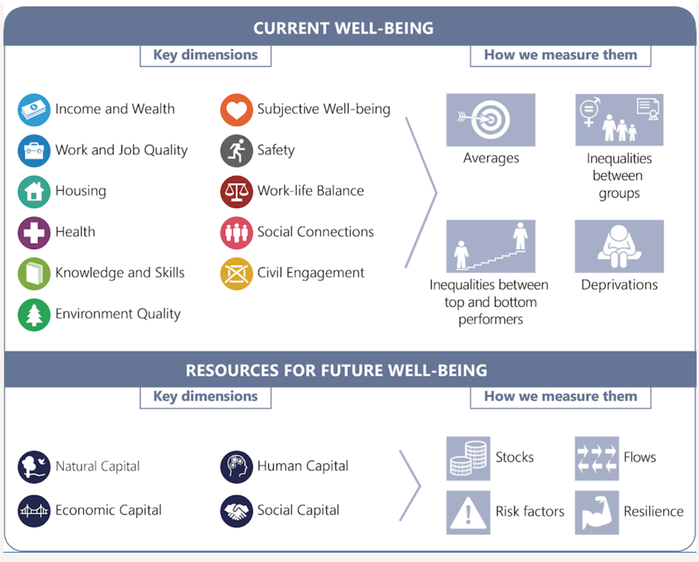
Figure 1
In terms of fairness, we should be thinking not just of the current generation but also are we leaving sufficient stocks of natural capital, human capital, the economic capital, and social capital for future generations? Are we being fair to future generations? There is a strong sustainability angle to the fairness framework here. You’ll also see this approach especially really like the Multi-Dimensional Poverty approach being reflected in the UN’s Sustainable Development Goals, 17 different areas there where there are indicators for each one of them (Figure 2). And, of course, the OECD has indicators for each of their areas as well.

UN Sustainable Development Goals
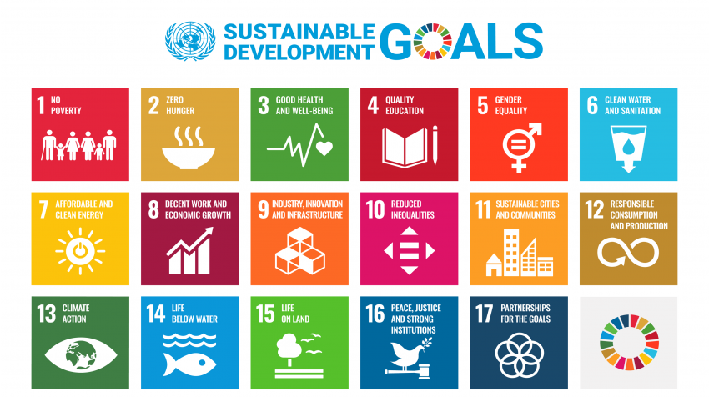
Figure 2

The question I ask as a person who is designing policy and who has been in the policy role for much of my life before I came to the academia, is how does one use dashboards like this to design policy? It’s all very well to have lots of indicators but how do we know which ones are the most important to address? For instance, if we have even the OECD or the UN’s SDG approach, if we saw people falling below a threshold in education and falling below a threshold on for example health, should we target our resources mostly to education or mostly to health? Which one would be more important? These approaches don’t actually help us to prioritize policy in that way. There is a gap in these approaches that yet has gone unmet.
The second main approach in the wellbeing policy space has been to rely on indicators of Subjective Wellbeing (SWB). Here I have Professor Richard Layard and Carol Graham, two main contributors to this, economists who are contributing to this area. Many others have in many different disciplines, psychology, sociology, philosophy, geography. The idea is really to reflect more the utilitarian philosopher’s idea of designing policies to maximize the society’s Subjective Wellbeing or the Subjective Wellbeing of people in society where we may give greater weight to people at the lower end of the scale. So, we may be trying to maximize or increase the Subjective Wellbeing of people who are currently having low wellbeing. Typically, in the literature, we have three classes of measures, different groups and measures of Subjective Wellbeing. One is evaluative wellbeing, which tends to be based on a measure of life satisfaction. I would like to show you some questions shortly and this really accords more with the economist’s idea of welfare or utility. There are measures of affect or happiness, anxiety, joy, these sorts of things. These are shorter-term indicators, and particularly used in the psychology literature. And then there is purpose in life sort of eudaimonia measures like the Bobby Kennedy discussion I had before. The nice aspect of the subjective wellbeing approach is that each measure is rated by the individual. It doesn’t require a paternalistic outsider to specify what’s important for wellbeing. Each individual person specifies what’s important for their wellbeing. These are now being used by economists in the United Kingdom, in New Zealand and elsewhere in what’s called Cost Wellbeing Analysis (WELLBYs) where we try and design policies not just to look at monetary measures of outcomes but in terms of wellbeing measures and the notion of WELLBYS or Wellbeing Years are being used.
In terms of an example of how we might use a measure of subjective wellbeing for policy, we might be wondering about the impacts of a particular policy on subjective wellbeing. For example, what Richard Layard uses is that for people who are depressed, a course in Cognitive Behavioral Therapy has been shown to lift their wellbeing. Just for my hypothetical example, I will say it lifts the wellbeing by one point on a scale of zero to ten. They might have started off as a four out of ten, now they rate their lives as a five out of ten. We can then estimate using statistical methods generally how many more dollars to yen would somebody require lifting their subjective wellbeing by one point. And we know that richer people tend to be happier. They tend to have greater life satisfaction. So, we can estimate that it might cost say $20,000 on average per year to lift somebody’s wellbeing by one point. In that case, we could say the monetary equivalent of a course in Cognitive Behavioral Therapy is $20,000. We can use that estimate then and Cost-Wellbeing Analysis to say the benefits that accrued from a course in Cognitive Behavioral Therapy is worth $20,000 in benefit terms. And then we can compare that with other measures and look at how much they increase subjective wellbeing by and see which provides the best value for money in policy senses. This is being used now. UK treasury’s Green Book which is their Cost-Benefit Analysis manual has this approach embedded in it and the New Zealand Cost-Benefit Analysis manual in New Zealand treasury also has these measures built into it.
In terms of how we measure evaluative subjective wellbeing, these are the two most common questions. The first one is a little longer than the other due to a person called Cantril from the 1960s. He says, “please imagine a ladder with steps numbered from zero at the bottom to 10 at the top. The top of the ladder represents the best possible life for you and the bottom of the ladder represents the worst possible life for you. On which step of the ladder would you say you personally feel you stand at this time?” People write down zero up to ten whichever number they feel they are in terms of how they rate their life as a whole. And a simpler measure is from the World Value Survey, “all things considered, how satisfied are you with your life as a whole these days?” And many general social surveys of statistical agencies around the world now use questions like these in their general social surveys. The Gallup poll uses the Cantril Ladder question in its survey of 160 countries or so around the world (Figure 3). These are used and have been shown to have a lot of very good statistical properties in terms of people’s decision-making etcetera. Steven Pinker, Peter Singer both philosophers and linguists, and Richard Eastland, famous economist, all of them advocate using these sorts of measures. One of the criticisms when these measures have been used in Western countries is that people in Western countries tend to gravitate towards seven or an eight, or maybe a nine when they are rating their lives on a zero to ten scale. But you’ll see that around the world, most people rate their lives as a five out of ten. And then it’s reasonably similar to a normal distribution around that, slightly more or the other and there is a slight bulge at 10 which you wouldn’t expect in a normal distribution. That’s mainly people either in richer countries or rich people in poorer countries. But overall, you see that many people rate their lives very low in these distributions.
Population-Weighted Distribution of Happiness, 2015-2017
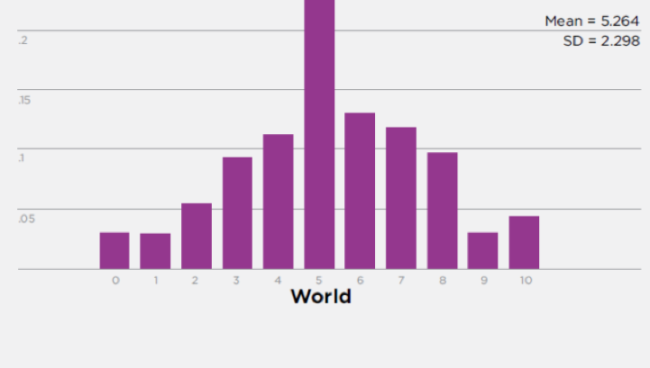
Figure 3(World Happiness Report, 2018, Gallup Poll Cantril ladder)

Based on the same measure, on the average for 2016-18, the top eight countries in terms of how people rate their lives and the bottom eight countries in terms of how people rate their lives (Figure 4). If you look at the length of the overall bar, you’ll see that people tend to rate their lives most highly in terms of their satisfaction with their lives mostly highly in northern European countries plus New Zealand, and Canada and Australia are also very close to New Zealand. At the bottom end of the scale are countries that you would not be surprised to see where people rate their lives very poorly are mostly war-torn or extremely poor countries. These measures seem to have a strong degree of validity.

Country mean life satisfaction (Cantril ladder measure), 2016-2018
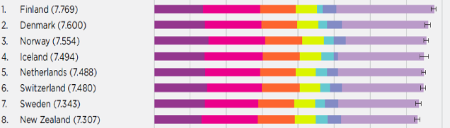
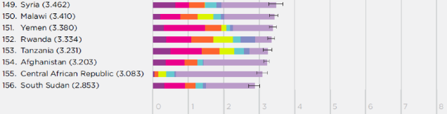
Figure 4 (Helliwell, et al 2019 from Gallup Poll data)
I mentioned that there are different measures of subjective wellbeing is the evaluative measure which is life satisfaction here. This is an OECD summary of how we might think about these different things (Figure 5). OECD says we have life satisfaction, we have affected measures like happiness or anger, and we have the eudaimonia measures such as purpose in life. And then, these different forms of subjective wellbeing maybe determined essentially by the capabilities that people have whether it’s related to their income, or their health, or their ability to make social contact and their culture etcetera. We can loosely think, and this is the way I tend to think is that one’s own subjective wellbeing is based on the capabilities that one has which reflects the opportunities and freedoms that we have. If we’re thinking about from a policy viewpoint, we try to improve subjective wellbeing, for example, life satisfaction, we probably have to work on these determinants of wellbeing, especially the determinants that effect people whose wellbeing is at the lowest ebb rather than for those who are at the highest ebb.

A Simple Model of Subjective Well-being
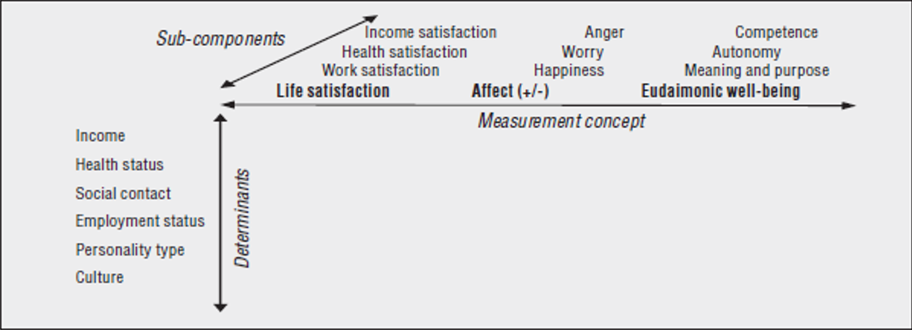
Figure 5

Subjective wellbeing approach can incorporate fairness. For a long time, we’ve used what’s called a Social Welfare Function to think about tradeoffs between the utility of different people (Figure 6). Theoretically, a Social Welfare Function describes policy-maker preferences for SWB/utility combinations across people. It includes classic utilitarianism and Rawls (maximin) as special cases, and it can be used for policymaker to trade off SWB inequality vs society’s “average SWB”. I’m just saying what I want to show is that this is not a particularly new concept in economics except for the use of the word ‘wellbeing’. Whether we just add together everyone’s utility in the way that maybe John Stuart Mill would have done, or we could think about purely increasing the utility of the person at the very bottom of the scale as Rawls would have done or somewhere in between. In practice, this is not a particularly new concept but it’s now reappearing as important.
When we look at inequalities though and fairness, we should look both at traditional measures of inequality and skewness. And inequality such as standard deviation and but in fact the two distributions maybe oppositely skewed. This is an example in a recent paper in Journal of Happiness Studies where we showed from the World Values Survey the distribution of life satisfaction in the Philippines and the Ukraine, and they are almost mirror images of each other (Figure 7). They have almost identical standard deviations but very differently skewed, one to the right and one to the left. Clearly, they have different implications for fairness. Just as a practical measure, when we’re thinking about measures, we shouldn’t just be relying on measures of whether of standard deviation or something similar, we should be also thinking how the distribution is skewed.

Alternative Views of Satisfaction with Life Distributions in
Government Objectives Philippines and Ukraine
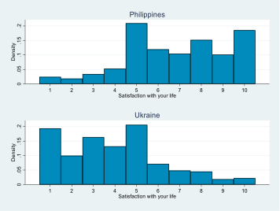
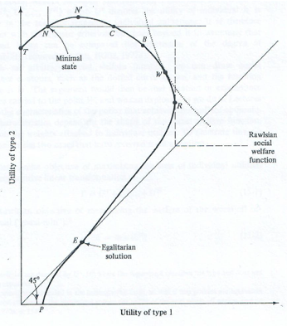

Figure 6 Figure 7

I would like to talk very briefly about some country experiences of using wellbeing for policy. I have to say what I’m going to say now is a cautionary tale where most of these experiences have not been very useful to this date although some have been better than others.
I will start off with the first country in this list, Bhutan. Bhutan is very well known for its approach from 1972 onwards in terms of prioritizing Gross National Happiness (GNH) instead of GDP (Gross Domestic Product). Bhutan’s approach though does not really maximize the national happiness. It’s a Multi-Dimensional Poverty approach. It sets thresholds for a whole host of indicators. It looks at how many people and which people are below the thresholds in an attempt to improve or reduce the degree of Multi-Dimensional Poverty. It’s not really built on a happiness idea, but on a Multi-Dimensional Poverty idea. Unfortunately, however, in practice there haven’t been large improvements in Bhutan over this time. That’s a period of 50 years now. So, the approach does not seem to have had very tangible benefits for people in Bhutan. I think we have to question how well that’s been implemented.
The Australian treasury came up with an approach, a wellbeing framework in 2004, which was built on both the capabilities and utilitarianism approach. But interestingly, they found it difficult to use for policy purposes and it was actually scrapped in 2017 and no longer used. So, they came with a beautiful framework, but it wasn’t very useful for policy. Similarly, in France a new law was passed in 2015 that the government had to set out new wealth indicators which were essentially wellbeing indicators, but they really have not paid attention to that since it was legislated even though it’s a part of the legislation and formally, they have to follow it, but they don’t. That hasn’t been very useful. In Wales, they passed at the same time the Wellbeing of Future Generations Act. This is probably the best model that I think has been used around the world. It’s one where each government agency has to state what their wellbeing goals are, and at the end of the year state how they have gained, whether they have met those wellbeing goals. The Auditor General, an independent assessor looks at whether those goals have been met and is also a person who acts on behalf of future generations to see whether future generations are being looked after. This is a very good model in my view, the Welsh model. The United Arab Emirates have a beautifully detailed Cost Wellbeing Analysis model but upsetting the country with abysmal human rights. We have to wonder how much they actually adhere to what they say. And in New Zealand, we have adopted something very similar to the OECD, Better Life Index, Who’s Life Approach with what’s called the Living Standards Framework, but it hasn’t been used to prioritize policy. In fact, the Cost Benefit Analysis approach has been more useful.
I would like to give some examples of how wellbeing maybe used as a guide for policy. I’ll quote some work from this World Happiness Report in 2013 relating to health. First, we know that bad health contributes negatively to wellbeing, but should we prioritize mental health or physical health when it comes to wellbeing? If government is trying to improve subjective wellbeing of people, overall evaluative wellbeing of people, they can look at measures of how people rate their physical health and their mental health and see which one is most closely related to their Subjective Wellbeing?
A work that’s carried out in that World Happiness Report, because these are standardized statistics one can compare the relative sizes of the contributors to life satisfaction and mental health problems or physical health problems (Figure 8). In this case, it’s where the people fall in the lowest quartile of life satisfaction. What it shows is that for each of Britain, Germany, and Australia, the impact of mental health problems is much, much greater on life satisfaction than with physical health problems. But we know that governments throughout the world spend vast amounts more on physical health than they do on mental health. This is suggesting as does much of the wellbeing literature that governments should be reorienting their health expenditures towards more expenditure on mental health issues rather than physical health issues. This is a way we can actually quantify which one’s more important. And at the moment, we can say it would be more important to increase resources to mental health issues rather than to physical health issues using life satisfaction as the arbiter if you like of the policy.

How Mental Health Affects Misery
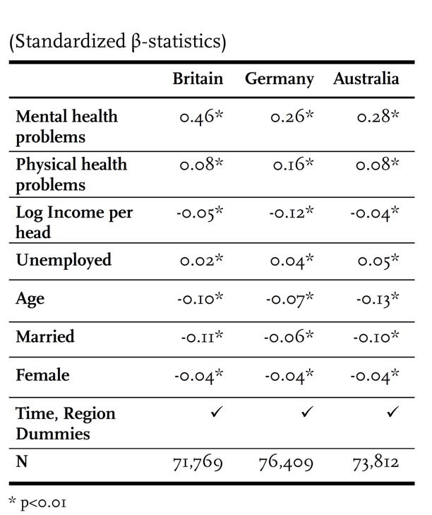
Figure 8

On the work side, we know that work is important for people’s overall life satisfaction. It also turns out that it’s very important for people’s emotions. If we look at measures of negative affect, in other words, unhappiness and anxiety, we see that people’s work status is very highly related especially people who are unemployed (Figure 9). These are people who are unemployed who would like a job, and the effect of being unemployed is a very strong effect on negative affect, in other words, very strong impact on negative affect. People who are unemployed have a very strong negative happiness effect. So, we can say well this really stresses the importance of getting unemployed people back into the workforce.

Importance of Employment Status for Negative Affect (Emotions)
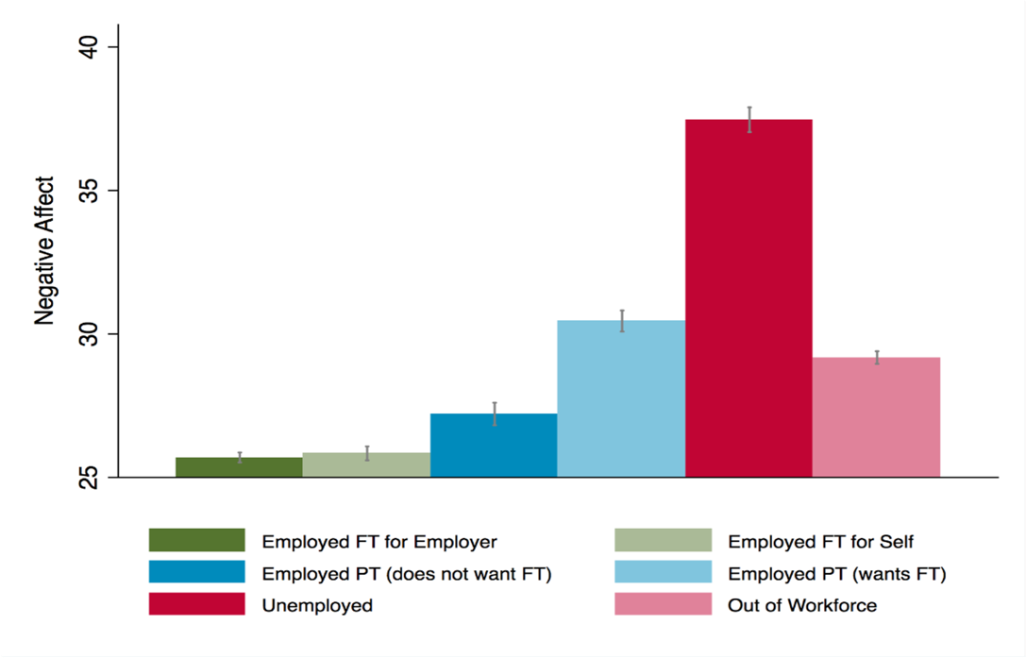
Figure 9

In New Zealand like the rest of the world, we have had COVID and lockdowns. Luckily in New Zealand, our statistics agencies started quarterly surveys of wellbeing as part of our quarterly health of labor force survey once COVID set in. We can relate these to the previous identical measures that were used in the general social survey for the adult population. Interestingly in this graph, this is just averages (Figure 10). Before lockdown in 2018, on average, life satisfaction in New Zealand was rated at 7.7 during the first lockdown, which was a nationwide lockdown with COVID. But towards the end of that lockdown as COVID was starting to ease, and life satisfaction had increased to 7.9. Even though we were still in a lockdown phase, and people’s life satisfaction went up. Partly this was because at that stage COVID was being overcome, given the eradication of COVID for a short time and so people were feeling pretty happy. We can see that people were generally happier. In the following quarter, in September quarter, there was an Auckland-specific lockdown, which is the largest city in New Zealand, with about a third of the country’s population. Overall life satisfaction in New Zealand went down with this second lockdown. And then, once that was relieved, once we had got rid of COVID a second time, people were very happy and the life satisfaction went up to 8. But we can use the Auckland lockdown example as one where we can say what’s the particular effect of lockdown in a particular region when the rest of the country is not locked down.
A Wellbeing Approach to COVID & Lockdowns
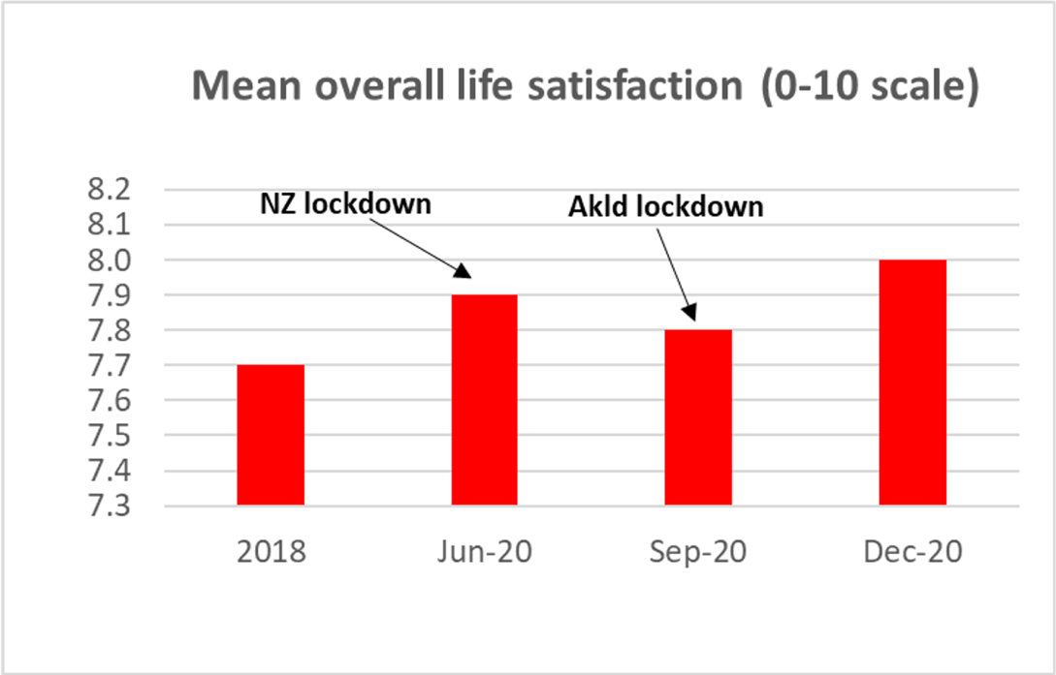
Figure 10

In a recent paper that we published, we showed we could estimate the effect of the lockdown in Auckland specifically relative to the rest of the country. And we could show that the lockdown reduced life satisfaction in Auckland with the lockdown. The effect was approximately two-thirds of the effect of being unemployed. Now we know that being unemployed is one of the worst things that can happen to you in terms of your life satisfaction. So, in effect size that’s roughly two-thirds of being unemployed was strongly material. One of the interesting things that we found in terms of fairness is that we looked at different groups of the population, and what we found is that actually for people who are unemployed in Auckland, their life satisfaction went up during that second lockdown. So, why might that be? We know from the international literature that if you are unemployed in an area with high unemployment then that’s not so bad because lots of people around you are in the same position. If you’re unemployed in an area where there is very low unemployment then you stand out, you’ve got a stigma attached to you. Therefore, from a fairness point of view, it’s very bad for your wellbeing if you are unemployed in an area with very low unemployment. We also see this in the United Kingdom. During a lockdown, if you are unemployed and no one else is going out to work, your life satisfaction actually increased which was quite an interesting thing. What we did find, however, is that loneliness increased with lockdowns. And from a fairness perspective, what we found was that loneliness increased particularly severely for sole parents. If we were thinking about repeating lockdown for another pandemic, we would think that the main fairness issue that we might have to address is how we deal with the situation of sole parents who were particularly hard hit being at home with children, not being able to see anyone. Then we would have to think particularly about how we can relieve the effects on them. This is an example of using a subjective wellbeing approach to see who is particularly affected by certain policies.
Richard Layard says that if you’re looking at personal wellbeing, it’s going to depend on your financial situation, your family and relationships, your work situation, community and friends, your health, your personal freedom, and your personal values which may include your religious values. That’s often seen to be a Western approach. Moreover, research reported in World Happiness Report 2022 into important of balance and harmony shows, traditionally values of balance and harmony were held more in East Asian countries, but according to the research, these values are actually prioritized in most countries. However, they are experienced more by people in rich Western countries. The people in rich Western countries perhaps have the money to be able to have a balanced and harmonious life because they are rich enough to be able to do so. Interestingly, it seemed to be cross cultural that people in virtually all countries preferred to have a calm life to an exciting life. Again, we might think of this as something that’s traditional in indigenous cultures perhaps East Asian cultures. But in fact, this was in virtually every country except one, I think the majority of people prefer the calm life to an exciting life. But those people who most want to experience a calm life tend to be from poorer places, probably from places who were not experiencing a calm life now. They are desiring to have a calmer life than they have now. This might raise an interesting agenda about the fairness of the current distribution of calmness, balance, harmony, both within and between countries.

Comment and Initiation of Discussion (by Assoc. Prof. Aaron Jarden)
I’m going to start with the way Professor Grimes started, and that was really, what do we mean by wellbeing? Here I think is potentially the biggest opportunity and the biggest challenge across both academia and for policymakers, and for real people and the way they live their lives. And by that, I mean I really don’t think we know what we mean by wellbeing. My experience of looking at interdisciplinary literature, so what policymakers publish, what positive psychologists publish in their field, what philosophers, what economist publishe, where rarely do they define wellbeing? When they do, it’s a very vague kind of definition of wellbeing at best.
In my field of positive psychology, probably as an example, the most commonly cited definition of wellbeing would be, ‘wellbeing is how people feel and how they function, at an individual and social level, and how they evaluate their lives as a whole’. That’s probably the most commonly cited definition. But when you hear it, it sounds like a pretty good shot at it. But when you unpack it, there is a lot inside. “How people feel” means we have got an emotions category. And “how they function” means we’ve got a behavioral category. “At individual and social levels” is talking about relationships between people so a social category, and “how they evaluate their lives as a whole” means we’ve got a cognitive category. All these different constructs and categories within this definition, each one of them can be unpacked and is complex. In the emotions category, all different types of emotions are important for wellbeing. People have different views on which ones are more or less important, and then not just the types of emotions but their actualization. It can really quickly become very complicated when we unpack how people define, and what they mean by, ‘wellbeing’.
Thus, in my work, whether that be delivering or developing a wellbeing program, I always start with “what does wellbeing mean to you?”. Ludwig Wittgenstein took the view that words get their meaning by how people use them in their language. So, we don’t so much start with a definition and a dictionary, but we ask people to unpack how they are using the term and what they understand by the term. In some of our research, we have asked very different types of people, nurses, teachers, lawyers, adolescents, Chinese individuals, students, all different types and ages of people, about how they conceptualize wellbeing or what that term means to them. And what we find is drastically different answers. Their models and how they understand wellbeing is totally different. For example, for an adolescent, the component of safety is important. For a Chinese student, balance and harmony is very important. For lawyers, teachers and for nurses, it’s relational. They all have a different model of what’s important for their wellbeing. When we take that one level data, we then ask about different types of wellbeing. For example, when we ask nurses what ‘wellbeing’ means to them, they will say it’s about having good mental health and having some enjoyment in life. And they will say it’s about work-life balance. But when we ask them what does ‘work wellbeing’ mean to them, not in their life but at work they answer with it’s about feeling respected, valued, and having good relationships. Generally, my first point is that wellbeing means different things to different people. My second point is that it also means different things in different context in different places for people as well.
The more we unpack what wellbeing means to people, I think we are finding very different recipes for what wellbeing is. It is a problem if we want to get a definition which is so straightforward that it encapsulates everyone. I think the answer we are moving to is that it’s actually different for everyone and what we need to start doing is unpacking what that is. Now that’s important if we want to get fairness because if you are in a position where wellbeing means something to you which is different to somebody else, and we’re trying to get a policy to mark something for both people, if they want different things, it’s going to be hard to write that policy.
Professor Grimes also talked about different cultural differences around wellbeing. The work of Mohsen Joshanloo, his Fear of Happiness Scale shows in fact there are cultures around the world with individuals fear being happy. This is because they don’t want to be perceived to have happiness because their wellbeing is really socially constructed, which are the issues we have. Our literature base, how we develop interventions, how we write policy, all these rely on understanding what exactly wellbeing is, which raise problems. When coming to the welfare that Professor Grimes mentioned, we could say quality of life or wellness. We could also list life satisfaction or lots of things that are used interchangeably in some of these literature bases, especially by the media, to mean ‘wellbeing’.
Probably the biggest problem, even bigger than that, is that when people talk about wellbeing mostly what they really mean is illbeing. They put wellbeing and mental health in the same category. Sometimes they refer to the whole definition. But people talk about wellbeing all the time. However, when you really get down to what they really mean, is illbeing. They are talking about stress, anxiety, depression, things going wrong with people, and using the term wellbeing to encapsulate illbeing. They are kind of using the term in a way which isn’t consistent with the way the average lay people use the term. That’s another problem which is intertwined with this.
That’s what I would like to say first, which is, I think one of the best advances we can make for policy is getting clear about defining wellbeing, what wellbeing means to people, and what could then go into those models of wellbeing that are important to people.
Second, when I think about wellbeing, fairness, and policy, I really think about you can’t really get wellbeing without first thinking about how people should live their lives. It is obviously a political question, but also has a strong lengthy history on ethics. In other words, the question ‘how should we live?’ is necessarily an ethical question, but it’s also necessarily a political question. And that overlap is there through the academic literature, and there through history as well. I think when we think how we should live our lives, you usually get the story from most people of ‘we want a life full of wellbeing’. We want some happiness, some things that come through the tradition of the academics. But we don’t really hear people saying so much about fairness than we do about wellbeing. For example, if I ask the average parent, what do you most want for your kids? They will answer they want health and wellbeing, but not living in a fair society? That aspect of fairness isn’t at the forefront of people’s minds as wellbeing. This links to the issues Professor Grimes was raising, which is ‘what are the necessary preconditions are for wellbeing?’, and what the determinants are that would be needed for somebody to have a life full of wellbeing. And the same issues for fairness. But if we are just sticking with wellbeing for a minute, there are things like they need health, they need some resources. They need that aspect of ‘freedom from’; freedom from war and some autonomy and ‘freedom to’ as well. This is thinking around what the preconditions are for wellbeing.
This is also a problem in the academic literature base because most of the research doesn’t really differentiate between wellbeing as an input, or an output. When you read articles in most disciplines, they are not very clear about whether they are talking about wellbeing as an input or as an output. Professor Grimes was really clear in the sense of looking at wellbeing as an outcome and how to measure it in regard to its relation to policy. But I think there’s another problem we need to think more about which is whether wellbeing is driving certain kinds of outputs or whether it’s the output we are interested in.
Another question came to my mind when Professor Grimes was talking about the UN Sustainable Development Goals. When that came out, my first initial impression of it way back then was maybe they are putting the horse before the cart here because what I think we want as societies in the world is really sustainable wellbeing goals of which development is a part or maybe sustainable flourishing goals. I was beginning to think about what happens when we don’t have wellbeing in a society or what happens when we don’t have fairness? There are some studies that predicted that countries where wellbeing really dropped, for example, the Arab Spring in Egypt. When their wellbeing really tanked that then led to massive upheaval and political controversy and changes in government. But we can say the same with fairness. People that live in societies that become unfair move away from their societies as well.
Moreover, what I also think interesting is that you mentioned that what COVID has really done is started a conversation about the importance of wellbeing. In many ways, people have gone through the COVID experience and thought more about what they really want out of life, which is something people really don’t take the time to do very often. It takes an event like COVID or a traumatic injury or something like that for people to do that. I think coming out of COVID, organizations, individuals are really starting to think about meaning and purpose and their wellbeing and the life they want to live which they didn’t necessarily, or at least to the same extent happened, before COVID. What hasn’t happened though is a similar conversation around fairness, but which I think it would be great if we could throw that into the mix as well. Many of the issues to do with COVID Professor Grimes identified weren’t really realized. We don’t have those conversations or discourses in the media or right circles about people that were unfairly impacted by COVID compared to others. For example, people with a low level of resources who couldn’t use resources to navigate through COVID better than people with a high level of financial resources that were able to use those to navigate through COVID better. I think we could clearly say that the COVID experience had an unfair impact across various people in society, which we seldom hear. We don’t see that conversation or policy to remediate that now which I think is unfortunate because that will have a generational impact. Partly it is because the discourse is really taken over from what are seen as bigger issues, such as the war in Ukraine, and the global financial crisis. I think that conversation would have been a good one to have.
The other thing about the COVID experience I think is really interesting is the people that have gone through that and come out better or have gone through the experience and benefitted from things like lockdowns are the ones that have tapped into essentially psychological skills which are not necessarily expensive. They are teachable skills such as tapping into social networks, thinking more about the meaning and purpose in life, developing a sense of self-efficacy that they can manage through struggle in times of tough things. I think it was the lost opportunity through COVID that we didn’t, in our society, really pivot to think about how they could grow through that. But also, I think that would have been a good combination with fairness to think about what would a fair and just society look like as people spring boarded from COVID, rather than all this discourse around economics and politics which I thought was overly dominant.
In addition, I would like to make a point about future generations and “fairness to who” which is an ethical question. And with the younger generations, we are really seeing a big move towards sustainability of the planet and towards consideration of future generations which is a bigger conversation including people and animals as well.

Comment and Q&A
Prof. Jiro Mizushima
One of the most interesting and even striking fact which was shown by Professor Grimes was that under COVID-19 the life satisfaction of people in New Zealand increased rather than decreased, which was quite different from the general assumption in other countries. As is well known New Zealand adopted a strict COVID-19 policy, and this policy was one of the strictest COVID measures in the world. But at the same time, it is considered that the New Zealand case is one of the most successful cases in the world. The COVID-19 mortality rate was low and life expectancy increased during this period. New Zealand had fewer cases, fewer hospitalization, and fewer deaths which I think is quite remarkable achievement.
However, in general, strict COVID measures including lockdowns and restrictions on people’s daily life could cause discontent and discomfort and criticism among citizens, which is widely thought. In European countries, we saw many criticisms from people against government measures. Sometimes we saw a large scale of resistance from civil society such as anti-doctor movement. In this sense, the situation in New Zealand was quite unique. As a political scientist, I think that the political leadership played an important role in New Zealand, especially the role played by the Prime Minister of New Zealand. The Prime Minister could deliver a clear message to the citizens during the pandemic about the critical situation in the country, and she could speak about what to do for the people. I think it is a quite successful political communication. By this way, people could understand what must be done by the people to overcome the crisis. As a result, COVID-19 did not have a huge negative impact on wellbeing in New Zealand I suppose. This development reminds me of the leadership of the German chancellor, Angela Merkel. She also could deliver a clear message to German citizens, and she kept sustainable support from German citizens. It was somewhat different from neighboring countries in Europe.
Generally, when people think the government or the politicians are doing the right thing, and the government is treating citizens fairly, people would accept the hard situation. It might foster the national unity and that sense of unity might increase life satisfaction. And my question is, what do you think about this political communication and political environment and what is its relationship with fair treatment and fairness?

Prof. Arthur Grimes
COVID-19 came to New Zealand at a time when we had a fairly new government and a very popular government where the young charismatic Prime Minister had been elected and had strong support to essentially change the way that politics was done in New Zealand essentially I think was probably the message if you like. She referred constantly to the team of five million in case you are wondering why five million that’s how few people we have in New Zealand. It’s a population of five million. So, it’s consistently that the team of five million can do this, the team of five million can do that. And what’s more it’s not just we are doing that to help the people who are most at risk of bad outcomes from COVID-19. She immediately gave people a reason that by being locked down in our own homes, we were serving the country by not giving COVID to people who would die from it. People felt they were rewarded in themselves that idea of eudaimonia, the purpose in life and had a purpose in lockdown. I think it was a very unusual situation that people felt good about being locked down in the first lockdown. I will say this in the very first lockdown almost everyone felt good about it.
There were a few people who had to work very long hours, obviously medical people or people working in supermarkets. But that’s a very small proportion of the population. Everyone else was essentially on holiday for a month. New Zealand has a high level of social capital. Another feature of this is we went into COVID with a long history of having amongst the highest trust in government of any country in the world and trust in other people. Trust in those social capital is very high in New Zealand. The Prime Minister Jacinda Ardern leveraged that high level of trust and willingness to help others. In fact, it was the situation where people were allowed to walk around the neighborhood as long as we didn’t go within two meters of another person because we only have five million people in a country the size of Japan. Everyone in every community was walking around the streets. There were no cars. Walking around the streets, meeting neighbors that they hadn’t seen for years, or meeting new neighbors, or people we know in other communities because we were allowed to walk around. It was the most extraordinary community event that lasted for one or two months. And so, people felt very good about that, and they were serving the country at the same time by being on a holiday. That’s how they felt very good. That was why life satisfaction went up strongly in that first lockdown, and we succeeded in eliminating COVID at that stage as the communication was superb.
When it came to the second lockdown which was more specifically targeted at Auckland, the beneficial effects had worn off. It was becoming clearer that maybe COVID will keep reappearing even we eliminated it but now we’ve got it again and we’re going to have to keep on going through the cycle. Also, people in Auckland felt the rest of the country has not been locked down much then worse off. They could see the rest of people still enjoying and they were not enjoying.
I think it came to this issue of that Professor Jarden referred to, the difference between freedom “from” and freedom “to”. We were all benefitting in terms of freedom from COVID. New Zealand as you see had a very low rate of COVID, very low rate of death. The lockdowns were keeping us free from COVID, but it was not giving us the freedom to go about our lives. In the first lockdown, no one worried about that because we all felt wonderful as we are serving the country and serving these people who are most at risk. Once it got to the second and then there was a third and fourth lockdown after that, people started prioritizing freedom. Some people started prioritizing freedom “to”. That’s where the dissatisfaction came in. Last year there was a huge protest, occupation of parliament grounds. These were the people that prioritized freedom “to”. They wanted to be able to go about their lives. By this stage, we had already introduced vaccine mandates. People lost their jobs because they refused to be vaccinated. And so, while the government was prioritizing freedom from COVID, they weren’t prioritizing freedom to go about your life. Once the freedom “from” had worn off, and the pleasure from that had worn off, many people started saying no. They want the freedom “to” go about life even if there is a risk of dying.
I think it’s lovely Professor Jarden have raised that the communications were fantastic to start with but weren’t so good later. I supported everything the government did through this period, but I don’t think the later communications kept people on side. They kept this fringe if you like onboard. Then the protests became violent. I think this whole area of leadership, but it also has to be leadership with a view that there are different, as Professor Jarden started off, what does wellbeing mean for you? Unfortunately, mainly for the civil servants who work in Wellington, freedom “from” was the most important, for most people who work here and so supported government. But people in government and officials are often out of touch with people in other parts of the country. And what was important for people in terms of the wellbeing of people in many other parts of the country was freedom to go about their lives. We had different conceptions of wellbeing. The officials here wanted to be paternalistic and look after people’s lives for them whereas many people didn’t want paternalism. They wanted to go about their own individual lives. This is where the whole wellbeing crux of policy becomes very difficult when people value different aspects of wellbeing. This is the point I think Professor Jarden made so eloquently, how do you design policy when people have different conceptions of wellbeing for themselves?
I will also comment on two other of Professor Jarden’s points. One is that when we refer to wellbeing, we are often referring to ill being. I think one of the good things about the wellbeing approach is that it is trying to reorient towards wellbeing as opposed to ill being. Traditionally we have talked about mental illness, we want to be improving people’s mental health. We don’t want to be just dealing with mental illness. We want to be improving mental health. We want to be improving people’s physical health, their opportunities etcetera. We might want to be raising the wellbeing of people who are not just at the bottom end of the scale but also higher up in the scale because there might be opportunities to raise the wellbeing of everybody. Many people who are well off, but their wellbeing is currently not nine or ten out of ten because their work-life balance is not good. They are working such long hours. For these people, we wouldn’t traditionally be thinking about policies to improve their wellbeing, when in fact we should be thinking about policies to improve their wellbeing if their work hours are too long. We should be thinking about how we can overcome these problems in many societies that people work too long hours. I think the emphasis on wellbeing is important rather than just the emphasis on ill being.
As Professor Jarden mentioned earlier, when I teach the course on public policy and the economics of wellbeing, we will also be starting with the question, what does wellbeing mean for you? I think that’s a wonderful opportunity to then get into and then actually I’ll mention the first assessment is going to be in contrast there with the two main approaches to wellbeing in the literature is to how you think wellbeing means for you relates to the literature? I think this helps us to think about these complexities of wellbeing approaches because of these individual ways of interpreting wellbeing.

Prof. Masaya Kobayashi
I firmly believe that your approach including SWB in wellbeing is very useful for policy analysis and policymakers. I believe such approach should proceed with a consideration regarding fairness. In our forthcoming books on fairness, one chapter on Japan proved that health conditions and various Japanese wellbeing has been influenced by fairness. Another article demonstrates that Japanese people’s health has been greatly influenced by income inequality and fairness. Our demonstration has been very similar to your ideas and the Western demonstrations.
As a political philosopher and public philosopher and I’m very interested in the relation between your wellbeing approach and philosophy and ethics. You mentioned with regard to economics, some approach has been derived from utilitarian approach and also capability approach derived from that and proves to another direction, but positive psychology approach has been argued that there are two kinds of wellbeing conception. One is hedonic conception of wellbeing. Another is ethical and eudaimonic conception of wellbeing.
So, my first question is, how do you think of eudaimonic conception of wellbeing because you emphasized the importance of SWB approach? And does such kind of consideration have relationship to the analysis or results just as Sen’s capability approach do that?

Prof. Arthur Grimes
The eudaimonic side I think what we see from the evidence is the eudaimonic factors are very important when it comes to people’s overall how they feel about their life. Given my disciplinary background saying people’s sense of eudaimonia feeds into their overall evaluation of their life. Somebody who thinks that doing something worthwhile is much more likely to have a higher evaluation of their life satisfaction. We see this in data that relates people’s occupations and income to their overall life satisfaction. There is a clear relationship in every country. The richer people on average tend to be happier. But when we look at that across occupations, we see that the average life satisfaction of people who described their role as a priest or reverend or religious figure, they don’t own much money, but they are very happy. Their life satisfaction is very high because one expects they have a very high level of eudaimonia. Other people who have jobs that are not highly valued in society, if you like in a status sense or an ethical sense, they might have very high incomes, but their life satisfaction is nowhere near as high as you would expect them to be given how much they are earning. The way people view the status and the purpose of their role in life tends to influence very strongly their overall life satisfaction. I have to say that economists and statisticians are bang on the line, the regression line for the relationship between life satisfaction and income. As you would expect, we are there exactly but other people, farmers for instance. Farmers, their life satisfaction is much higher than you would expect given their income like priests. So I think eudaimonia is a very important part.
However, I don’t think it’s something the government can do much about. I think this is something that comes back to personal ethics, personal family situation, your upbringing. Individuals can do something about it not the government except in a very isolated instance of say the first lockdown in New Zealand where we all felt like we had a purpose in life which was to be on holiday. And I think it’s very important but probably not in the area for public policy to concentrate on particularly unless they can really think of something.
The second area is in terms of the ethics side. Different philosophers come to these things from different angles. I mentioned Peter Singer, a great Australian philosopher, who is these days pretty much a utilitarian, basically saying that we should be thinking about people’s overall evaluation of their life. Interestingly, he is very similar to Jeremy Bentham in the sense that he says but we shouldn’t just be thinking about people. This should be referred to all people. From a fairness angle that’s important. Both Singer and Bentham say this should also extend to animals, which I think is an interesting situation. We can be thinking about even from a utilitarian perspective. But this doesn’t mean that it has to be purely human-centric. There is quite a challenge as to how far you take this beyond humans and then you know which animals etcetera. But I guess the ethical position I have is that these concepts should apply to all people. I think both Bentham and Singer would say that, and Sen would say that as well. To me that’s just a very nice starting point. If we were prepared to have this philosophy for some people, we should have it for everyone. Then an issue would be raised as Peter Singer pointed out, if we had this purely utilitarian approach and we want to improve the welfare or wellbeing of people in our country, why would we limit that just to people in our country? Why wouldn’t we use in a rich country? why wouldn’t we vastly increase our overseas aid contribution to increase the wellbeing of people outside of our country? Ethically how do we make a distinction between helping people within our borders and the wellbeing of people outside of our borders? New Zealand has a very low level of foreign aid, and we accept very few refugees. Under this current government despite being a wellbeing-oriented government, we have had also a very strongly anti-immigration policy whereas previously in non-wellbeing-oriented governments we have had a very open immigration policy.
So, there are some challenges here I think as to how we think ethically who should be covered by these wellbeing policies. I can see from a political angle, obviously every government wants to concentrate in their own countries for the people who vote for them. These are things that governments have to do but I do question whether we draw the line too narrowly.

Prof. Masaya Kobayashi
My impression from your answer is that you obviously recognize the importance of eudaimonic conception of wellbeing, but you said that government policy which leads to value judgments should be cautious. I think you obviously are positive for utilitarian or subjective wellbeing approach in considering public policy. But you are very careful of other kinds of ethical considerations, for example communitarianism. Is my impression right or not?

Prof. Arthur Grimes
I have a very strong belief in the importance of rights. To me, the underpinning of capabilities as Sen would argue as well, opportunities and freedom etcetera. They are also the underpinnings of subjective wellbeing. One could say I’m purely seeing that as a means to an end, hugely important as a means to an end. In fact, I have just written a paper currently being reviewed at a journal on who benefits most from freedom of speech using data from around the world for a long time. Interestingly, there could be two hypotheses in this. One could think freedom of speech is most valued by rich people. If you think about Maslow’s hierarchy of needs, once you got self-actualization, you can afford to think about freedom of speech. On the other hand, you can say freedom of speech is most important for the marginalized. And so that’s the only way they can make their concerns heard. We tested this in terms of this relationship with subjective wellbeing. It often changes over time across countries and found that it actually helped the marginalized the most. Freedom of speech was the most important for the marginalized. From a purely sort of positivist angle I could say freedom of speech is important because it helps the wellbeing of the people at the bottom end the most.
I would probably go further than that however in my own personal ethics and say freedom of speech is important no matter what. But then of course we still have those issues that we have to address. What about hate speech? What about misinformation? How far do we allow freedom of speech? And these are topics obviously of major importance at the moment. I’m not purely positivist, but I do think there is an inherent right to freedom in general, human rights in general, but I think they also have a very strong positive play in here.
And I think we should make sure the policy does not prevent people from leading a life that they value, a good life or eudaimonic life. I don’t think they can do much to promote it, but I think it should make sure that it’s not preventing it. It can certainly prevent it as we see in many countries.

Assoc. Prof. Aaron Jarden
I am a New Zealander who is based in Australia now. I see New Zealand, having come from New Zealand, as a resilient country. It has those farming values of ‘get on with the job’ built in. New Zealand has a strong degree of resilience, but it also has had a lot of leaders in the past which were very visionary, and future-focused such as Sir Edmund Hillary and Sir Peter Blake. It’s a country which really pulls people into a future compared to what I have experienced here in Australia.
In terms of Professor Grimes’s comment about what policymakers could do in regards to teaching around eudaimonic wellbeing, I think what we are experiencing here in Australia is what I would love to see in New Zealand and elsewhere. It’s a great drive within the education system for a new field called positive education. When I think about how we can get more wellbeing or fairness, the biggest vectors which we can reach people through is through schools and education, or through work. Through school and education, many of the private schools, public schools, the Catholic schools have been intentionally teaching people the skills of wellbeing, particularly around eudaimonic wellbeing, about how to think about meaning and purpose in life, and how to figure out what their strengths are, how to utilize them more. These aspects and issues, and research on these is clearly demonstrating that once they leave school, the links go from wellbeing to engagement, engagement to productivity, productivity to success. Wellbeing is a real driver of economic outcomes which it clearly shows that as well.
What I would love to see policymakers do is really to start their conversation about what their education system is for. We have passed the industrial revolution now. It’s not really about just knowledge, but about skills. And what are those skills beyond academics that really should be built into our education system? That’s where I would love to see policy around actually teaching the skills of wellbeing. But beyond that it’s not just about wellbeing, but philosophical skills around reasoning. We can have discussions and debates, which I think would be hugely important as well.

Prof. Takayuki Kawase
I have a question for Professor Grimes about the meaning and definition of wellbeing which is probably related with the comment of Dr. Jarden. I am afraid that the idea of wellbeing is so broad and general that it looks sometimes logically trivial, which means anything good would be included into the category of wellbeing. There is no logical space outside the idea of wellbeing. And if so, by referring to the idea of wellbeing we can say anything, even totally opposite things at the same time, even something contradictory. For example, the argument for the strict rule of quarantine of COVID and the loose rule of quarantine at the same time. They are completely opposite but possibly inside the same theory. So, by using the idea of wellbeing, what idea can we exclude from our discussion?

Prof. Arthur Grimes
The way Professor Kawase put the last bit I think is superb, what should we exclude from the definition? I remember being at an economics conference once before when somebody had a theory. Somebody asked that sounds so general, what predictions would it exclude? I think it’s a great way of thinking that.
From my perspective and this reflects I guess my training as an economist, I like to leave the judgment of wellbeing up to an individual person rather than government. That’s why I’m not keen on big checklists of lots of different indicators of wellbeing because one could say we are doing these policies and some of the indicators have gone up, some have gone down, all these sorts of things like in the Better Life Index of the New Zealand treasury’s approach. I think I tend to look at it and say the closest measure we’ve got that’s useful for policy often are measures of self-rated subjective wellbeing such as life satisfaction. And so, if I asked somebody how satisfied you are overall with your life, and I do that before a policy and after a policy and I have a control group and a treatment group. And I can see the life satisfaction of the treatment group has gone up relative to those who weren’t treated especially if the treatment was random. Then I think that is a measure of self-rated satisfaction with their life that’s gone up as a result. So ideally, we would want that to be a randomized controlled trial where some people got treatment, some people didn’t, and we could see whether the things went up.
Now I’ll give you an example of where that’s been used in my own work. Recently, we were asked to evaluate a small program that the government subsidizes poor households in New Zealand to put in a heat pump which is the most efficient form of electric heating. And before we were asked to evaluate this, we looked at the life satisfaction of each person in the study. We then monitored their homes for temperatures and all sorts of things as well. Then they got their heat pump which was turned out to be randomly timed because of lockdowns. There was a supply chain problem. When they got the heat pump, it turned out to be completely random. Then we had a second survey for people some of whom had received their heat pumps, some hadn’t, and some might had had them for three months. In the second survey, we repeated the same questions as in the first survey including questions on life satisfaction. And what we could tell is that people who received the heat pumps and had them for longer, not just had received them but they had received them now for a few weeks as opposed to just having received them, their life satisfaction on average went up relative to the control group if you like of people who hadn’t received them or having just received them recently. That seemed to be a reasonable indicator that this program not only had benefits on electricity use and temperature, but people actually felt better about their lives as well. And to me that’s one way we can use these concepts of public policy to have any effects beyond the tangible things we can measure in a useful way. Another example, if we randomized between treatment of depression through drugs or through Cognitive Behavioral Therapy, which of those has the larger effect on somebody’s overall satisfaction with their life? They are both treatments for depression, but we can see whether one group has increased their satisfaction with life more than the other group. We can use that as a measure. I suppose we have to start somewhere and for public policy as it is an additional piece of information that we didn’t have before.
It is useful when we expect policies to have a large effect on somebody’s overall satisfaction with their life if we are using a life satisfaction measure. It’s not so useful for smaller things. We do have measures as well which come back to measures of affect, short-term joy, inner satisfaction etcetera, which are increasingly being run now with people with smart phones. What you do is sending them a little message at a particular time, at random time during the day asking what they are doing now, who they are doing it with, and how they rate their joy, happiness right now instead of their overall satisfaction with their life. That can be useful for looking at much more specific policies which could be much more useful at the local level. For instance, we are working now with public housing tenants using that technique, especially people who are using it with you and need a green space now. You can look at the effects of being in and around nature and green space. But if they happen to be near green space now and they are feeling happy about it then you can measure that. That may not influence their overall life satisfaction. I think we are starting to get some better measures of some of these things and using them which are all experimental and giving us more insight.

Mr. Alfonso Torrero
In terms of life satisfaction, I read an article about Mexican young adult life satisfaction where uncertainty was one constant word in their life perception and worries. For example, they expressed uncertainty about maintaining their jobs, having enough resources for a comfortable life. It probably shows that many Mexican young adults have a low subjective wellbeing score. In addition, social stigma and social pressure tends to silent young adult’s perceptions and opinions. Having this in mind, could you describe one successful policy, or can you think about one successful policy that helps to raise subjective wellbeing of a population sector that feels undervalued or lives in uncertainty as an example?

Prof. Arthur Grimes
I think you are correct that issues of job uncertainty and other forms of uncertainty reduce overall life satisfaction. I think there is no doubt about that. You also mentioned social pressure. One thing I did not mention really in my first talk but in the talk is that the way people value their overall life is very relativistic. It’s very much done in terms of how you see where you are relative to other people. I did mention the unemployment example. Much better to be unemployed in an area with higher unemployment than an area with low unemployment because everyone around you is in the same boat.
I’m trying to think of a particular example which has been used to improve the life satisfaction of particular groups. I mentioned the area of green space. People have done some experiments in terms of just trying to improve the natural environment for people. There is some evidence that that can improve people’s lives. People are much better when they are surrounded by green space than when they are in a heavily built-up urban environment with no green space. As I said, the work that I’m doing in New Zealand now shows that just improving, making houses not being so cold. New Zealand houses are very cold traditionally. For some reason, people moved to New Zealand from Europe thinking that we are a warm Pacific country, but it is not. It is a cold Pacific country, but they built houses as if it were a warm Pacific country. The work that we are doing, the government is doing, and we are evaluating to improve the group of the population that are poor, poorer, and live in cold houses that really does. We show that this reduces their wellbeing. And if you improved their insulation and their heating opportunities and things like that that actually improves their wellbeing because they are no longer subject to so much cold. We’ve got some quite good evidence that we can use public policies to improve the wellbeing of certain groups that we know are particularly at risk in this case poorer people who live in cold houses.
I am trying to think of an example though where something has been evaluated to reduce the uncertainty that people face. That would be an interesting example. I’m sure somebody has but for the life of me I can’t think of a study which said here has been a policy intervention that is basically designed to reduce people’s uncertainty. To some extent our first lockdown in New Zealand did when there was uncertainty about COVID-19, then uncertainty about jobs and at the same time the government put in a very large wage subsidy so that most people retained employment through a very severe lockdown. That reduced people’s uncertainty, but we can’t attribute the rise in wellbeing to that reduction and uncertainty as there might have been other things. But I think that would be an excellent research project to see if there was a policy that reduced people’s uncertainty. For example, leaving education and being guaranteed a job which reduces one of the big uncertainties in life for young people.
I should mention the people of Central America, Mexico through to northern half of South America where most of Latin America in fact tend to have high values for life satisfaction, much higher than we would expect given their incomes such as Mexico and Costa Rico. For example, Costa Rico has democracy, very strong human rights, fantastic nature, and it has superb attachment of social capital, friends and family. It meets a lot of the tests for high life satisfaction even though it’s a middle-income country. Its life satisfaction tends to be higher than United States or the United Kingdom. In other words, you can make up for lack of income through some of these other features that are important.

Assoc. Prof. Aaron Jarden
I think Mexico probably has the best example of a wellbeing University in the world. For example, Techmilenio and Tecnológico de Monterrey, the only university where every single student in every single discipline does a wellbeing course and learns the skills of wellbeing, and that’s why it has the highest graduate employment rate in the universities in the world potentially. In terms of Professor Grimes’s point about money and wellbeing, I totally agree with evidence that those with more resources have a slightly higher wellbeing, but that difference isn’t huge. One of the results we got out of the New Zealand Wellbeing Study was that people living within their means had much higher wellbeing than those that didn’t. For example, people that earned 200,000 dollars a year but spent it all, their wellbeing was quite low or they were feeling stressed. But people earning just 50,000 dollars but were living within their means had very high wellbeing. We figured out that the odds ratio, or that the power of that relationship, was much more potent than the sheer amount of money they were earning.
When we look around countries in the world, some of the happiest people in the world live in the slums of Kolkata. They don’t have a lot of resources, but they are living within their means, and they are spending time on eudaimonic aspects. They are spending time with their kids. I think there’s an aspect to this that’s important as well and that could be a policy directive because again that’s a teachable skill on how to manage wellbeing.

Atkinson A & Joseph Stiglitz. 1980. Lectures on Public Economics (Economics Handbook Series). New York: McGraw-Hill Book Company.
Grimes, A., Jenkins, S. P., & Tranquilli, F. 2023. “The relationship between subjective wellbeing and subjective wellbeing inequality: An important role for skewness”. Journal of Happiness Studies: An Interdisciplinary Forum on Subjective Well-Being, 24(1), 309–330.
Gallup World Poll, Years 2014 to 2016, Weighted by Country; Confidence Intervals 95%; FT: Full-Time, PT: Part-Time.
Grimes A. 2022. “Measuring Pandemic and Lockdown Impacts on Wellbeing”, Review of Income and Wealth, 68(2), 409-427.
Richard Layard. 2005. Happiness: Lesson from a New Science. London: Penguin Press.

